COFFIN BONE FRACTURES

Thursday, September 11, 2008

**[Coffin bone fractures: What to look for...](https://www.behindthebitblog.com/2008/09/coffin-bone-fractures-what-to-look-for.html)**

[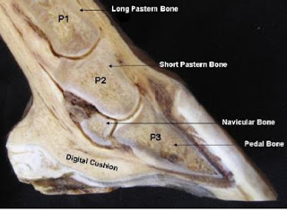](https://2.bp.blogspot.com/_IS6u0pZVIIQ/SMcLQW5bVxI/AAAAAAAADC4/_4CO_PC8yzc/s1600-h/coffin.JPG)**What is the coffin bone?**  
The coffin bone goes by several names, including the third phalanx, PIII, distal phalanx, or pedal bone. It is a [half-moon shaped](http://www.johnthevet.com/images/anat4.gif) bone completely encapsulated by the hoof (P3 in the cross sectional photo on the right). This bone, which is rough and pitted in texture, is surrounded by the delicate tissue called the laminae. The laminae and digital cushion support and protect the pedal bone. There are many tendons/ligaments attaching to the coffin bone (particularly in the back of the hoof), as well as a network of blood vessels surrounding it. Within this support structure, you also find the navicular bone nestled in the back of the pedal bone. The deep digital flexor tendon passes over the navicular bone and attaches to the bottom of the pedal bone. An [excellent article](https://www.blogger.com/www.healthyhooves.co.uk/hoof_anatomy.pdf) from [Healthy Hooves](http://www.healthyhooves.co.uk/) can be consulted for more information about hoof anatomy.  
  
This structure of bones and tissue supports the weight of the horse and absorbs the impact of forces acting on the legs from walking, trotting, jumping, etc. Anything compromising this support system can jeopardize the soundness of the animal and possibly its life. The pedal or coffin bone is the centerpiece of this complex structure.  
  
[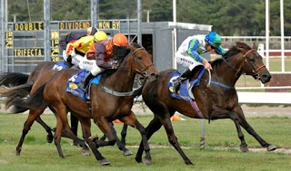](https://2.bp.blogspot.com/_IS6u0pZVIIQ/SMcUIOYYJzI/AAAAAAAADDA/GQ7RE1iiCus/s1600-h/LEGS.jpg)**Injuries to the pedal bone**  
What kinds of horses are vulnerable to pedal bone fractures? The problem is most commonly diagnosed in race horses and other performance horses, as it is an injury that stems from stress and abnormal force acting on the hoof. Young horses also seem to be at risk, in part because they are so active and their bones are not fully developed. Pleasure horses can also sustain a pedal fracture from such mishaps as kicking a wall, stepping on a rock, or running on hard ground. Over 90% of coffin bone fractures occur in a forelimb.  
  
**What are the signs of a coffin bone fracture?**  
The signs of a coffin bone fracture are similar to such common problems as a stone bruise, abscess, or laminitis (except that laminitis occurs in both feet). The symptoms present can include:

* Sudden onset of lameness in one leg, usually a front leg though not always
* Severity can range from moderate to non-weight-bearing pain
* Heat
* Digital pulse
* Swelling in the coronary band

Often only a few of the above symptoms are present, and in varying degrees. The cause is often mistaken for a stone bruise or abscess. [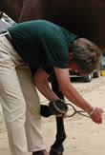](https://3.bp.blogspot.com/_IS6u0pZVIIQ/SMcZrdqsJTI/AAAAAAAADDQ/tA3h5W0qQvM/s1600-h/hoof_testers.jpg)**How is it diagnosed?** The best, most definitive way to distinguish between a coffin bone fracture and other ailments is to take radiographs. If a suspected abscess or bruise does not progress as expected, it may be safest to a) call the vet and b) limit the animals exercise until a definitive diagnosis can be made. **The veterinary evaluation** Vets have their own routine for evaluating lameness and I won't try to list the various tests they might do -- after all I'm not a vet! I will mention some tests that seem to be important for diagnosing a pedal bone fracture according to the reading I did. Hoof testers seem to be a good tool for targeting the source/location of hoof pain. If a pedal bone fracture is suspected, the location of pain might suggest the type of fracture. If the center of the pedal bone is cracked, testers would show pain generalized across the surface of the sole. Sometimes the outline of the crack can be traced with the testers--the horse will react most strongly along the crack line. If the wings/edges of the pedal bone are fractured, the horse would show more pain in one heel. Manually squeezing the heels together would also elicit a pain reaction. [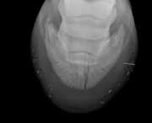](https://1.bp.blogspot.com/_IS6u0pZVIIQ/SMguGUqdE_I/AAAAAAAADDg/NCz4hEtpZ-c/s1600-h/pedal_bone_fracture.jpg)**Radiographs/x-rays** Radiographs provide a definitive diagnosis. However, a crack may not show up on x-rays for a week or so after the injury. It may be wise to either delay x-rays for a week (keeping the animal on stall rest). This gives the body time to remove some of the bone from the fracture line, making it more visible. Alternatively, the horse can be transported to a facility for a bone scan, which is far more sensitive and can detect subtle/hairline cracks.

*A note on nerve blocks:* Some veterinarians like to do nerve blocks as part of diagnostic testing. A horse that is nerve blocked will not "protect" the compromised bone when trotting, since the pain is gone; this could worsen the injury. If this type of test is used, experts strongly recommend that the nerve block be postponed until x-rays are performed on a horse that has been stall-rested for 10 days or more, so that the injury has the best chance of showing up. In other words, nerve blocks should be done *after* a pedal bone fracture has been ruled out.

**Types of fractures** There are actually seven kinds of pedal bone fractures as shown in this graphic from a [super article](http://www.thehorse.com/ViewArticle.aspx?ID=4784) in *The Horse*. Generally speaking, any fracture that involves a joint interface will be more serious. Types 1 and 2 are most likely to heal well without lasting negative effects.

[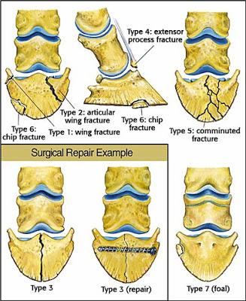](https://4.bp.blogspot.com/_IS6u0pZVIIQ/SMcYYKISQ9I/AAAAAAAADDI/DgMASvAkjac/s1600-h/coffinbonefx.jpg)

**Pinpointing and treating the injury** The best case scenario is an injury to the outer wing with no joint involvement. This type of injury is less severe at the outset (most pain is on the affected quarter of the hoof). While a fracture in this location is harder to immobilize, motion is less detrimental than on a joint. This type of injury tends to knit together with flexible cartilage and carries the best chance of the horse returning to its former level of work. Injuries involving the joint surface have a more guarded prognosis. Immobility is critical because the bone reforms with more bone that is brittle and inflexible. with a joint surface fracture, surgery to immobilize the bone (with screws) may be necessary. Surgery is used to compress and fix the fracture gap. Surgery helps to minimize defects in articular cartilage of the coffin joint that occurred as a result of the fracture. Large defects in the articular cartilage may lead to the development of arthritis. [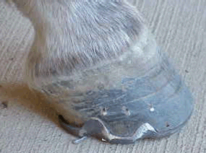](https://2.bp.blogspot.com/_IS6u0pZVIIQ/SMcfZl-KulI/AAAAAAAADDY/WrtvYw33M44/s1600-h/leftfrontbarshoemedial.gif)Invariably, a horse with a coffin bone fracture will require therapeutic shoeing, usually bar shoes with quarter clips and padding. The goal is to prevent expansion of the back of the hoof, thus limiting motion/action on the coffin bone. The horse should be shod this way for 3 to 6 months. The shoes are typically in place for 6 to 8 months. Some horses may return to light work after this, while others may be on stall rest for a year. **Prognosis** Young horses with fractures often do quite well with conservative treatment (non-surgical) because their coffin bone is not fully developed until the age of there. For older horses are better candidates for surgery, and they are more likely to have subsequent arthritis. In one study of hundreds of horses with fractures, about 1/2 return to their former level of work. **RESOURCES** [The Racing Journal](http://www.theracingjournal.com/health/article.php?article_id=494), Jan. 5, 2006 [Dealing with a broken foot](http://www.thehorse.com/viewarticle.aspx?ID=4784), *The Horse Magazine*, Nov. 1 2004, by Katherine J. Meitner [Coffin bone fractures](http://www.aaep.org/health_articles_view.php?id=73), advice article from the AAEP. Section of coffin bone fractures in [Practical Guide to Lameness in Horses](http://books.google.com/books?id=0HeO3I8MGFcC&pg=PA210&lpg=PA210&dq=%22coffin+bone+fracture%22&source=web&ots=8U1tVPoHG0&sig=L5AlGbJS-kTYao_xjQb7_8eXPK0&hl=en&sa=X&oi=book_result&resnum=3&ct=result) by Ted Stashak [Coffin bone is susceptible to concussion injuries](http://www.thoroughbredtimes.com/horse-health/1996/September/07/Coffin-bone-is-susceptible-to-concussion-injuries.aspx), *The Thoroughbred Times*, Sept 7, 1996 [Dealing with a broken foot](http://books.google.com/books?id=-uoaGHgT8H0C&pg=PA147&lpg=PA147&dq=%22coffin+bone+fracture%22&source=web&ots=6y9FsiaMN9&sig=vZAHAsYJO8HMOv24Mc77tdfl2Pw&hl=en&sa=X&oi=book_result&resnum=1&ct=result), The Horse magazine, Nov. 1, 2004, by Katherine J. Meitner [Veterinary Topics: A hard and fast injury](http://www.equipodiatry.com/distlphl.htm) , Thoroughbred Times, Sept. 6 2003. A longitudinal study of racehorses with coffin bone fractures. Most returned to racing. [UC Davis Book of Horses: Complete Medical Reference](http://books.google.com/books?id=bYwabwEPnzkC&pg=PA216&lpg=PA216&dq=coffin+bone+fracture&source=web&ots=5cHirNc8Vu&sig=IExpwEAkAAn1TNoVKHSMJ05C0Hw&hl=en&sa=X&oi=book_result&resnum=5&ct=result) Section on coffin bone fractures [Coffin bone fractures in young horses](http://www.cvm.ncsu.edu/vth/ehc-sp/ehic/cbf.html) from the NCSU Vet School (examines the incidence of fractures of the wing of the coffin bone in young horses)

[Email This](https://www.blogger.com/share-post.g?blogID=6317822193674196694&postID=1677833951991894068&target=email)[BlogThis!](https://www.blogger.com/share-post.g?blogID=6317822193674196694&postID=1677833951991894068&target=blog)[Share to Twitter](https://www.blogger.com/share-post.g?blogID=6317822193674196694&postID=1677833951991894068&target=twitter)[Share to Facebook](https://www.blogger.com/share-post.g?blogID=6317822193674196694&postID=1677833951991894068&target=facebook)[Share to Pinterest](https://www.blogger.com/share-post.g?blogID=6317822193674196694&postID=1677833951991894068&target=pinterest)